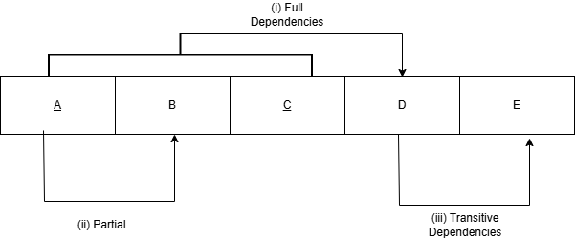
- Identify the dependencies labeled.
- Full dependencies
- Partial Dependencies
- Transitive dependencies

- Show 2NF dependencies diagram

- Show 3NF dependencies diagram

